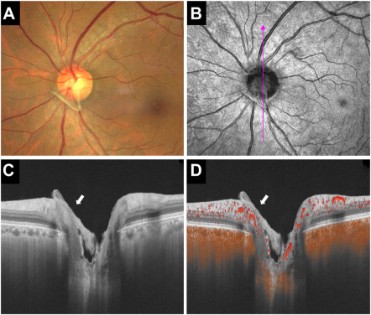

A 55-year-old asymptomatic woman was found to have bilateral abnormalities of the optic nerve during an ophthalmic examination.Ocular examination revealed visual acuity of 20/20 in both eyes with normal anterior segment. Fundus examination showed grayish-whiteglial tissue covering the optic nerve (A) as confirmed by infrared image (B) from OCT. Cross-sectional OCT image (C) exhibitedhyperreflective membrane overlying the optic disc, and adhesions to adjacent optic papilla structure (white arrow). The corresponding OCTangiography B-scan with flow overlay (D) showed hyperreflective tissue without any flow signal, contrasting with the optic disc’s normalblood flow signa. Based on the provided images and clinical description please make an ophthalmic diagnosis for this patient. And output the diagnostic conclusions only.

**Optic Disc Pit**